|  |  |  |  |
| --- | --- | --- | --- |
| 2 | | 9,864.0 | |
| NUMERO DE FRONTERAS | | ENERGIA AGREGADA | |
|  | | | |
| SI | | 26-10-2020 | |
| CONTRATO | | VENCIMIENTO CONTRATO | |
|  | | | |
| 28,644,018 | 88 | | 1,050,111 |
| INGRESO 2019 | DÍAS CERTIFICADOS 2019 | | ENERGIA RESPALDADA 2019 |
|  | | | |
| 35,201,512 | 179 | | 1,308,379 |
| INGRESO 2020 | DÍAS CERTIFICADOS 2020 | | ENERGIA RESPALDADA 2020 |
|  | | | |
| 13,694,319 | 61 | | 594,892 |
| INGRESO 2021 | DÍAS CERTIFICADOS 2021 | | ENERGIA RESPALDADA 2021 |

|  |
| --- |
| **CC PORTAL PRADO**  USUARIO |

|  |
| --- |
| **Edwin Torres**  Ejecutivo de cuenta |

|  |
| --- |
| **Jose Struen Martinez / Jefe de Mantenimiento / mantenimiento@portaldelprado.com**  Primera fecha: PUNTO FOCAL |

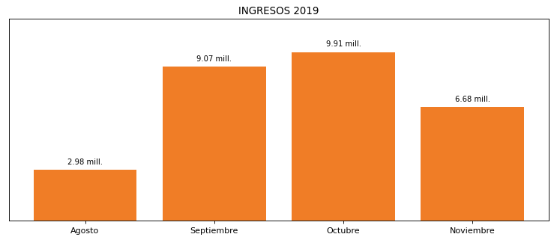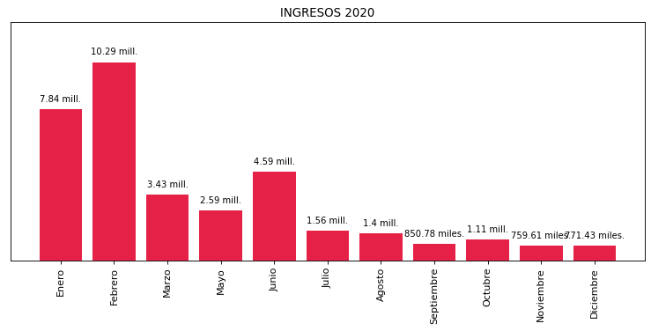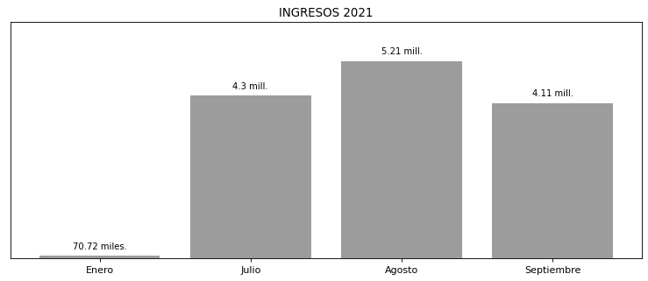

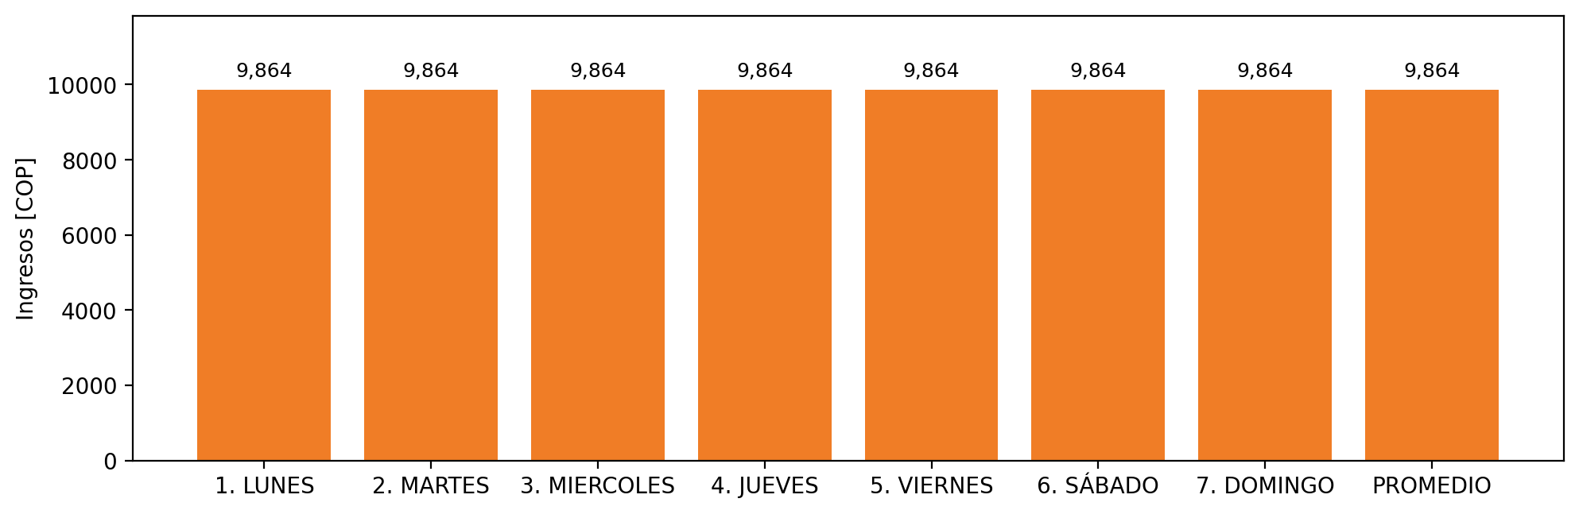

|  |  |  |  |  |  |  |  |  |  |
| --- | --- | --- | --- | --- | --- | --- | --- | --- | --- |
| **FRONTERA COMERCIAL** | **TIPO DDV** | **COD SIC** | **PREDIO** | **PROMEDIO** | **MARGEN** | **ÚLTIMA DESCONEXION** | **DÍAS CERTIFICADOS** | **ACTUALIZACION** | **PROXIMA PRUEBA DDV** |
| CENTRO COMERCIAL PORTAL DEL PRADO | Frt41758 | Frt07297 | Prd01390 | 9,864 | NO APLICA | 2021-06-30 | 60.0 | 2026-04-15 | 2021-11-30 |